DOCUMENT 02 — Master Data Collection & Resource Guide
Visionary Internal · v1.0 · The syllabus spine everything else hangs on.

Bad data is worse than no data: the AGI teaches what is in the database. Every node must
come from an OFFICIAL government source, verified character-by-character.

1. The 7-level hierarchy
Board → Class → Subject → Textbook → Chapter → Topic → Concept.
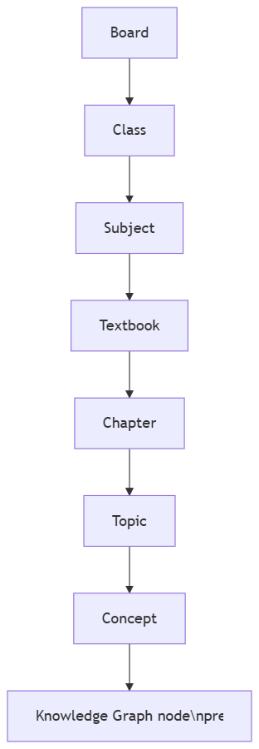

2. Source policy
OFFICIAL ONLY: NCERT · CBSE Academic · DIKSHA · NTA · state SCERTs · e-PG Pathshala.
Every node stores data_source_url + last_verified_date. Stale >12 months = re-verify.
No third-party content, no scraped PDFs of dubious provenance.

3. Coverage map
- 36 state boards + UTs.
- Engineering: JEE Main, JEE Adv, BITSAT, VITEEE, SRMJEEE, MHT-CET, WBJEE, COMEDK, KCET,
AP/TS EAMCET, KEAM, JCECE + more (15+).
- Medical: NEET UG, NEET PG, AIIMS, FMGE.
- Others: UPSC + 11 state PSCs, banking (IBPS/SBI), SSC, railway, defence (NDA/CDS),
teaching (CTET/TET), technical (GATE), law (CLAT).

4. Curation flow + manual fallback
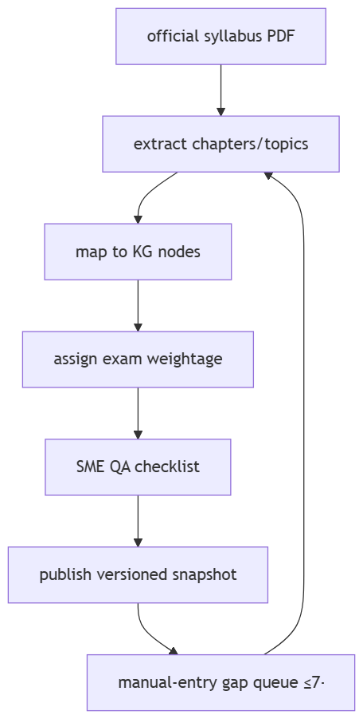
Manual upload exists ONLY for edge cases (a board PDF missing online); it enters the gap
queue and is replaced by the official record within 7 days.

5. Build priority
Phase 1: CBSE + JEE + NEET + ICSE + JEE-Adv (beachhead). Phase 2: high-population state
boards (UP, Bihar, WB, MH, TN, TE, KA, GU). Phase 3: remainder + long-tail exams.

6. QA checklist (blocking)
Chapter names match TOC exactly · chapter counts match · weightage from current-year doc
only · latest textbook edition · is_in_current_syllabus cross-checked · subject naming
per board · medium code ISO · source URL present · manual entries converted ≤7 days.

OKF
KF1: 0 wrong chapter names in prod. KF2: 100% Phase-1 coverage before beta. KF3: gap-SLA
≥95%. KF4: every node has source URL + verified date. KF5: versioned snapshots rollback-safe.

